**Software Requirements Specification**

**For FRC Scout**

Version 1.1

February 11, 2013

**Prepared by:**

Kristian Calhoun

Keith Horrocks

Hannah Pinkos

Jirakit Songprasit

Ryan Hersh

Drexel University

**Revision History**

|  |  |  |  |
| --- | --- | --- | --- |
| Name | Date | Reason | Version |
| Kristian Calhoun, Keith Horrocks, Hannah Pinkos, Jirakit Songprasit, Ryan Hersh | January 29, 2013 | Initial Version | 1.0 |
| Kristian Calhoun | February 11, 2013 | Added requirements 0275, and 0947, edited 0946, and indexed use case descriptions. | 1.1 |

**Table of Contents**

1. Introduction 5

1.1 Purpose 5

1.2 Background 5

1.2.1 About the FIRST Robotics Competition (FRC) 5

1.2.2 About Ultimate Ascent 6

1.3 Scope 6

1.4 Glossary 7

2. Overall Description 8

2.1 Product Perspective 8

2.1.1 User Interface 8

2.1.2 Hardware Interface 8

2.1.3 Software Interface 8

2.1.4 Communication Interfaces 8

2.1.5 Memory Constraints 9

2.2 User Characteristics 9

3. Specific Requirements 9

3.1 Functional Requirements 9

3.1.1 User Accounts 9

3.1.2 Security Requirements 11

3.1.3 Event Data Management 11

3.1.4 Team Data Management 12

3.1.5 Match Record Data Management 13

3.1.6 Viewing Entered Data 15

3.2 Non-functional Requirements 17

3.2.1 Compatibility 17

3.2.2 Performance 17

3.3 User Interface 17

4. System Evolution 22

4.1 Support For Future FRC Games and Custom Match Records 22

4.2 Support For Match Schedule Input 22

4.3 Match Planning Reports 22

4.4 Organization Support For Distributed Use 23

4.5 Scrape Information From the FRC Website 23

5. Use Cases 24

5.1 Use Cases For All Users 24

5.1.1 Login 24

5.1.2 View information and statistics 25

5.1.3 Sort Data 27

5.1.4 Search for matches 27

5.1.5 Search for teams 28

5.1.6 Upload Robot Picture 28

5.2 Use Cases for Scouts 28

5.2.1 Add Team 28

5.2.2 Manage Previously Entered Match Record Data 29

5.3 Use Cases For Administrators 30

5.3.1 Manage User Accounts 30

5.3.2 Manage Event Information 31

5.3.3 Manage Team Data 32

# 1. Introduction

## 1.1 Purpose

This document provides the requirement specifications for FRC Scout. The requirements include the specifications of the motivation for the development of the system, functional and non-functional requirements, user interface attributes, long-term ideas for the evolution of the system, and use case diagrams and explanations.

FRC Scout allows users, who are members of a single FIRST Robotics

Competition (FRC) team, to input data about the performance of each robot competing at a FRC event into a graphical user interface. The program then stores the information and computes simple statistics. The system then allows users to view the data in a graphical format and sort the information based on different user-selected criteria.

## 1.2 Background

### 1.2.1 About the FIRST Robotics Competition (FRC)

The FIRST Robotics Competition (FRC) is an international high school robotics competition. Teams of students work with teachers and engineering mentors to design, build, and program a 120-pound robot to compete in a game challenge that changes each year. The 2013 game is called “Ultimate Ascent” and is played with two alliances (red and blue) of three teams each. Teams are given a strict six-week deadline in which to complete their robots. After this time is up, teams compete at regional events in order to qualify to attend the world championship. Over 2,500 teams will compete in the 2013 season at 77 different regional competitions during the 2013 season.

Each regional event and championship division, consisting of 30-100 teams, follows the same structure. Teams compete in a series of 9-12 qualification matches. During these qualification rounds, alliances are randomly assigned so that a team’s partners in one match may be their opponents in the next. At the conclusion of the qualification rounds, teams are ranked based on their win-loss-tie record. The top 8 teams then participate in an alliance selection draft in which they each select two other teams to join them as part of a permanent three-team alliance moving forward. These 8 alliances then compete in a double elimination tournament to determine the event winners.

To aid in the alliance selection process, many teams have students, known as “scouts,” record data (usually on paper) about the performance of each team’s robot in their qualification matches. This data then has to be organized and analyzed to reveal the strengths of each team. Depending upon a team’s own strategy, they will rank and sort all of the other teams according to different criteria to see which is the best at each aspect of the game. This information is then used to decide which robots would make the ideal alliance partners for the elimination rounds.

### 1.2.2 About Ultimate Ascent

Ultimate Ascent is the name of the 2013 FRC game. Each match lasts two minutes and fifteen seconds and is played by two opposing alliances consisting of three teams each. The primary objective of Ultimate Ascent is to score as many flying discs as possible into goals of three different heights. These low, middle, and top goals are worth 1, 2, and 3 points respectively.

A match begins with a fifteen second Autonomous Period in which robots operate following pre-programmed instructions. Any points scored during this period are worth double. Robots are then remotely operated by human drivers for the remainder of the match, known as the Teleoperated Period, where they attempt to score even more discs. Towards the end of the match, robots can earn bonus points by climbing a ten-foot tall pyramid structure. The higher a robot climbs on the pyramid, the more points it receives (either 10, 20, or 30 points). Scoring special colored discs into a small goal located on top of the pyramid earns an alliance even more bonus points (5 points per colored disc). The alliance whose robots score the most total points is the match winner.

## 1.3 Scope

This document describes the software requirements for the FRC Scout program, which is to be used by FIRST Robotics Competition Team 25 at the 2013 Las Vegas Regional. The initial release will be tailored specifically to the 2013 FRC game, Ultimate Ascent. Developers are expected to use this document as a guide in their creation of the system and testers will use it as a basis for validating the release of the product. The intended audience of these requirements also includes end-users who are interested in the program’s functionality and future evolution.

## 1.4 Glossary

**Administrator** An administrator is a user with the “administrator” account privilege. In addition to the team member and scout user permissions, administrators can modify or delete any data in the system, add new events to the system, and manage user accounts.

**Event** An event is a single regional competition or championship division. Each event is defined by its date, name, and list of attending teams.

**Game** The term game refers to each year’s unique FRC game. For example, the 2013 game is called Ultimate Ascent.

**Hypertext Markup Language (HTML)** HTML is the primary markup language used to display web pages in web browsers.

**Hypertext Transfer Protocol (HTTP)** HTTP is the standard protocol for communication on the World Wide Web.

**JavaScript** JavaScript is a client-side scripting language commonly used to implement user interfaces and dynamic content on websites.

**Match** In the context of FRC Scout, a match refers to a single qualification match played at an event. Each match has a match number and matches are played sequentially at an event. A match can also be identified by the six teams playing in it.

**Match Record** A match record is a unique collection of data relevant to the game for a particular team in a particular match at a particular event.

**Scout** A scout is a user with the “scout” account privilege. In addition to having team member permissions, a scout can also input new data into the system or modify previously entered data.

**Team** A team refers to a group of people who field a single robot at an event. All teams are assigned an official, permanent team number upon registering for the FIRST Robotics Competition. Each team also has a team nickname by which it can be recognized.

**Team Member** A team member is a user of the system with the “team member” account privilege. Team members have basic permissions to login, view, filter, and search for data.

**User** A user is a person who owns an account in the FRC Scout system.

# 2. Overall Description

## 2.1 Product Perspective

Members of FRC teams need a way to organize, analyze, and visualize their scouting data in ways that are not practical to do with a paper-based system. FRC Scout will allow users to input their scouting data into a graphical user interface. The system will store user information and provide different perspectives (event, team, and match views) for reviewing the data. Each view will contain sortable tables and dynamic graphical representations displaying team performance over time. The system will allow multiple team members to log in to the system at once to enter and view their collective data simultaneously.

### 2.1.1 User Interface

FRC Scout provides a web-based graphical user interface for viewing and entering data. The user interface is accessed using an HTTP 1.1 and HTML 4.01 compliant web browser that has JavaScript enabled.

### 2.1.2 Hardware Interface

The FRC Scout client can be run on any hardware meeting the following criteria:

* Capable of connecting to the same network as the FRC Scout server.
* Capable of running an HTTP 1.1 web browser
* Capable of running an HTML 4.01 compliant and JavaScript enabled web browser.
* Includes a keyboard and a pointing device.

The FRC Scout server can be run on any hardware meeting the following criteria:

* Capable of connecting to the same network as the client(s).

### 2.1.3 Software Interface

**Client** The FRC Scout software interfaces with the user’s HTTP 1.1 and HTML 4.01 capable web browser.

**Server** The FRC Scout server software runs on an operating system that supports serving dynamic web pages.

### 2.1.4 Communication Interfaces

Communication between the FRC Scout client and server will be accomplished via standard HTTP 1.1 over TCP/IP.

### 2.1.5 Memory Constraints

The hardware running the FRC Scout server will require no greater than 1 gigabyte of RAM and no greater than 1 gigabyte of storage space. The hardware running the client will require at least 512MB of RAM, as recommended by most modern web browsers.

## 2.2 User Characteristics

Users of the FRC Scout client only need to have a vague familiarity with the FIRST Robotics Competition and a basic, high-level understanding of the rules and objectives of Ultimate Ascent in order to comprehend the system. Since the system is specifically targeted at FRC participants, this knowledge is assumed to be known.

# 3. Specific Requirements

|  |  |
| --- | --- |
| **Priority** | **Description** |
| 1 | Priority 1 items have the highest level of importance and are necessary for usability of the product. The items labeled priority 1 must be completed prior to the release of the product. |
| 2 | Priority 2 items are not crucial to the usability of the product, but would enhance user experience and are expected to be implemented in the next release of the product. Priority 2 items not completed prior to release would not inhibit functionality of the release version of the product. |
| 3 | Priority 3 items are not crucial to the usability of the product and are not within the current scope of the system. These items are expected to change with future development. |

## 3.1 Functional Requirements

### 3.1.1 User Accounts

0000 **User Account Types and Privileges** The system classifies user permissions based on user roles assigned to user accounts. **Priority 1**

0010 The system defines the following user roles:

0020 Team Member **Priority 1**

0030 Scout **Priority 1**

0040 Administrator **Priority 1**

0050 The system must always have at least one Administrator account. **Priority 1**

0100 **User Account Creation** - The system shall allow for the creation of user accounts. **Priority 1**

0110 The system shall support the creation of any number of user accounts, only limited by the amount of available memory**. Priority 1**

0120 The system shall only allow administrator accounts to create new user accounts. **Priority 1**

0130 The system shall require the following information for the creation of a new user account:

0140 *E-mail Address* - A valid email address used for login credentials shall have up to 254 characters, and must be of the format address@domain.extension where address, domain and extension are not blank. **Priority 1**

0150 *Password* - A valid password shall have between 6 and 30 characters. **Priority 1**

0160 *First Name* - A valid first name shall have between 1 and 30 alphabetic or '-' characters. **Priority 1**

0170 *Last Name* - A valid last name shall have between 1 and 30 alphabetic or '-' characters. **Priority 1**

0180 *Role* - A valid role must be one of [0020-0040]. **Priority 1**

0190 **User Account Modification** - The system shall allow for the modification of user accounts. **Priority 1**

0200 The system shall only allow administrators to modify user account details. **Priority 1**

0210 The system shall only allow administrators to modify user account details as specified in [0140-0180]. **Priority 1**

0220 **Deleting User Accounts** - The system shall allow for the deletion of user accounts. **Priority 1**

0230 The system shall only allow administrators to delete user accounts. **Priority 1**

0240 The system shall prevent a deleted user account from logging in to the system. **Priority 1**

### 3.1.2 Security Requirements

0260 **User Account Authentication** The system shall only allow authenticated users to access system contents other than the login page. **Priority 1**

0270 The system shall require the user to supply a valid email address and password (as specified in 0150-0160) that match an existing user account to log in. **Priority 1**

0275 The system shall allow the user to log out of the system. Once logged out, the user must log in again, as specified in 0270. **Priority 1**

### 3.1.3 Event Data Management

0280 **Event Creation** The system shall allow for new events to be added to the system. **Priority 1**

0290 The system shall only allow administrators to create new events. **Priority 1**

0300 The system shall require the following information to create a new event:

0310 *Event Name* - A valid event name shall have between 1 and 100 characters. **Priority 1**

0320 *Location* - A valid event location shall have between 1 and 100 characters. **Priority 1**

0330 *Start Date* - A valid event start date shall be in the form 'mm/dd/yyyy' where mm, dd, and yyyy are nonnegative integers. **Priority 1**

0340 *End Date* - A valid event end date shall be in the same form as [0330] **Priority 1**

0350 *Game type* - A valid game type shall be selected from one of:

0351 Ultimate Ascent **Priority 1**

0360 **Event Data Modification** The system shall allow for event information to be modified. **Priority 1**

0370 The system shall only allow administrators to modify event information. **Priority 1**

0380 The system shall allow administrators to modify event details as specified in [0300-0330]. **Priority 1**

0390 **Event Deletion** The system shall allow for the deletion of events from the system. **Priority 2**

0400 The system shall only allow administrator to delete an event. **Priority 2**

### 3.1.4 Team Data Management

0410 **Team Creation** The system shall allow new teams to be added to the system. **Priority 1**

0420 The system shall only allow users with the roles of scout or administrator to add new teams to the system. **Priority 1**

0430 The system shall require the following information to add a new team to the system:

0440 *Team Number* - A valid team number shall be a positive integer no greater than 9999. **Priority 1**

0450 *Nickname* - A valid team nickname shall have between 1 and 250 characters. **Priority 1**

0460 *Location* - A valid location shall have between 1 and 250 characters. **Priority 1**

0470 **Team Data Modification** The system shall allow for team information to be modified. **Priority 1**

0480 The system shall only allow administrators to modify team information. **Priority 1**

0490 The system shall allow administrators to modify team details as specified in [0440-0460]. **Priority 1**

0500 **Team Deletion** The system shall allow for the deletion of teams from the system. **Priority 2**

0510 The system shall only allow administrators to delete a team. **Priority 2**

### 3.1.5 Match Record Data Management

0520 **Match Data Creation** The system shall allow for the entry of new match record data. Priority 1

0530 The system shall only allow users with the role of scout or administrator to enter new match record data. **Priority 1**

0540 The system shall require certain information when entering a new match record depending on the game type of the currently selected event. **Priority 1**

0550 The system shall require the following information when entering a new match record for game type [0351]:

0560 *Event Name* - A valid event name must be the name of one of the events previously added to the system as specified in [0310]. **Priority 1**

0570 *Match Number* - A valid match number shall be a nonnegative integer. **Priority 1**

0580 *Team Number* - A valid team number must be a team number associated with a team previously added to the system as specified in [0440]. **Priority 1**

0590 *Alliance Color* - A valid alliance color must be either red or blue. **Priority 1**

0600 *Number of discs scored in the top goal in autonomous mode* - A valid number must be a nonnegative integer. **Priority 1**

0610 *Number of discs scored in the middle goal in autonomous mode* - A valid number must be a nonnegative integer. **Priority 1**

0620 *Number of discs scored in the bottom goal in autonomous mode* - A valid number must be a nonnegative integer. **Priority 1**

0630 *Number of discs scored in the top goal in teleoperated mode* - A valid number must be a nonnegative integer. **Priority 1**

0640 *Number of discs scored in the middle goal in teleoperated mode* - A valid number must be a nonnegative integer. **Priority 1**

0650 *Number of discs scored in the bottom goal in teleoperated mode* - A valid number must be a nonnegative integer. **Priority 1**

0660 *Number of discs scored in the pyramid goal in teleoperated mode* - A valid number must be a nonnegative integer. **Priority 1**

0670 *Level on the pyramid that the robot climbed*- A valid level must be an integer in the range 0 - 4, inclusive. **Priority 1**

0680 *Robot play style* - A valid robot play style must either be “offensive” or “defensive”. **Priority 1**

0690 *Confidence in selecting the robot as an alliance partner* - A valid confidence rating must be an integer in the range 0-5, inclusive. **Priority 1**

0700 *Ability of the robot to pick up discs* - A valid ability rating must be an integer in the range 0-5, inclusive. **Priority 1**

0710 *Did the robot commit fouls?* - A valid answer must either be true or false. **Priority 1**

0720 *Did the robot commit any technical fouls?* - A valid answer must be either true or false. **Priority 1**

0730 *Comments* - A valid comment must have less than 500 characters. **Priority 1**

0740 *Autonomous Path* - A valid path is drawn with a pointing device in an area of 540 pixels by 270 pixels. **Priority 3**

0800 **Match Data Modification** The system shall allow for match record information to be modified. Priority 1

0810 The system shall allow only administrators or scouts to modify match record information. **Priority 1**

0820 The system shall only allow scouts to modify match records that were created by that user. **Priority 1**

0825 The system shall allow administrators to modify any existing match records. **Priority 1**

0830 The system shall allow administrators and scouts to modify match record details as specified in [0580-0740]. **Priority 1**

0840 **Match Deletion** The system shall allow for the deletion of match records from the system. **Priority 2**

0850 The system shall allow only administrators or scouts to delete a match record. **Priority 2**

0860 The system shall only allow scouts to delete match records that were created by that user. **Priority 2**

0865 The system shall allow administrators to delete any match records. **Priority 2**

### 3.1.6 Viewing Entered Data

0870 The system shall allow all users to view entered data. **Priority 1**

0880 The system shall display all match record data entered by scouts. **Priority 1**

0890 The system shall display all team information details entered by scouts or administrators. **Priority 1**

0900 The system shall display all event details entered by administrators. **Priority 1**

0910 **Data Grouped by Event** The system shall allow the user to view raw and calculated data associated with a selected event. **Priority 1**

0920 The system shall allow the user to change the currently selected event. **Priority 1**

0930 The system shall display the team number of teams that participated at the selected event. **Priority 1**

0940 The system shall display the total number of points scored (a weighted sum of [0600-0670]) by each team that participated at the selected event. **Priority 1**

0942 The system shall display cumulative totals of the data described in [0600-0670] for each team at the selected event. **Priority 1.**

0944 The system shall allow the user to hide or display different data fields. **Priority 2.**

0946 The system shall allow the user to sort all of the teams at the selected event by any of the totals described in 0940 and 0942 in ascending order. **Priority 1**

0947 The system shall allow the user to sort all of the teams at the selected event by any of the totals described in 0940 and 0942 in descending order. **Priority 1**

0950 The system shall display a breakdown of the type of points, [0600-0670], scored by each team in a selected match that took place during the selected event. **Priority 1**

0960 The system shall allow the user to change which match is selected to display the data detailed in 0950. **Priority 1**

0970 The system shall allow the user to view the complete match record data for any team in any match as described in 0560-0740. **Priority 1**

0980 The system shall allow the user to view a breakdown of the type of points, [0600-0660], a selected team scored per match that took place during the selected event**. Priority 1**

0990 The system shall allow the user to change which team is selected to display data detailed in 0980. **Priority 1**

1000 **Data Grouped by Team** The system shall allow for the display of raw and calculated data associated with a team independent of a selected event. **Priority 2**

1010 The system shall allow the user to select which team’s information is currently being displayed. **Priority 2**

1020 The system shall display the team data as specified in [0440-0460]. **Priority 2**

1030 The system shall display all events in which the team participated. **Priority 2**

1040 The system shall display the calculated average of all types of points scored by the team at each event in which the team participated. **Priority 2**

1050 The system shall allow the user to upload a profile picture for the team that is no larger than 2MB. **Priority 3**

1060 The system shall display a profile picture as specified in 1050 if one has been uploaded. **Priority 3**

1070 The system shall allow the profile picture to be changed by uploading a new picture that meets requirements specified in 1050. **Priority 3**

1080 The system shall allow the user to view the points scored in each match in which the selected team has competed. **Priority 2**

1090 The system shall allow the user to view all of the full match records collected for the selected team. **Priority 2**

## 3.2 Non-functional Requirements

### 3.2.1 Compatibility

2000 The web pages served by the system shall be viewable in HTTP/1.1 and HTML 4.01 compliant browsers with the ability to execute JavaScript. **Priority 1**

2010 The FRC Scout server shall be able to run on any operating system. **Priority 2**

### 3.2.2 Performance

3000 The system shall have a response time no greater than 1 second. **Priority 1**

## 3.3 User Interface

Below are sample graphical representations to demonstrate the functionality of the user interface. These graphics do not represent the final design of the user interface.

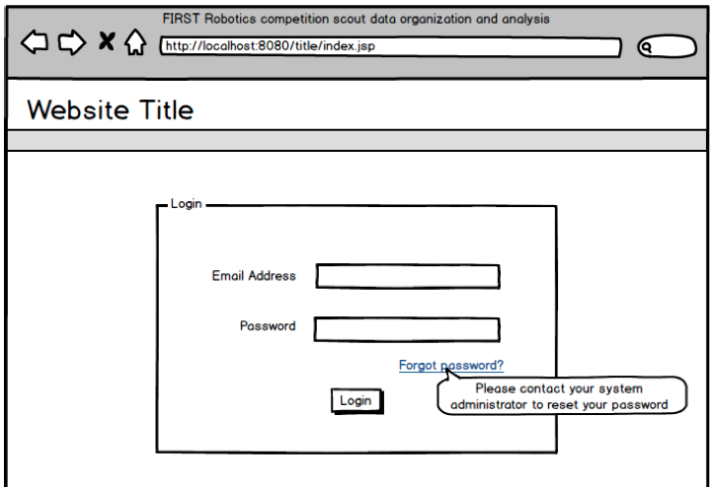

**Figure 3.3.1** The user login page functions to authenticate user accounts before a user is granted access to other pages in the system. The page contains fields for the user to enter an e-mail address and password. The user will be directed to the event overview page (Figure 3.3.2) after entering valid login information and clicking the login button (detailed in 0260-0270]).

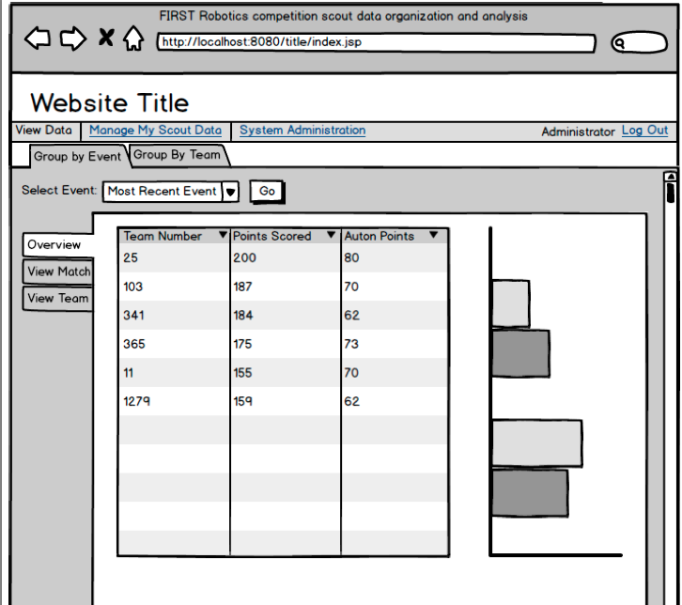

**Figure 3.3.2** The event overview contains a table and graph that display data related to the selected event. When the page is first opened, the data from the most recent event will be displayed. The selected event can be changed from this page. Additionally, data in the table can be sorted in ascending or descending order by a particular data point by clicking the appropriate column header. Other data views, such as the content on the ‘View Match’, ‘View Team’, and ‘Group by Team’ tabs seen in this image, have a similar layout and functionality. The view can be changed by clicking on one of these tabs.

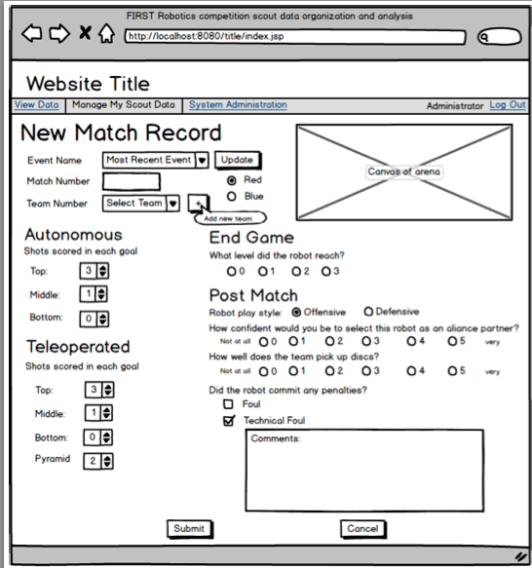

**Figure 3.3.4** The enter new match record page contains a form field for each datapoint, allowing the user to enter relevant data about the match (refer to [0560-0730]). The page also contains a canvas that allows the user to draw the path of the robot on an image of the arena, referred to in 0740. The user can click submit to save entered information or cancel to return to the previous page. Pages that scouts and administrators use to enter new data into the system have a similar layout and functionality.

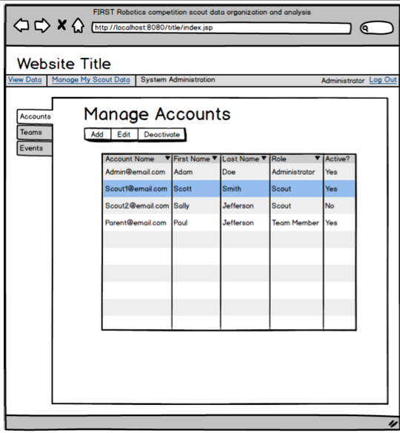

**Figure 3.3.5** From the manage accounts page, administrators can view data for registered user accounts. Accounts to be edited or deleted can be selected by clicking the entry in the table and then clicking the appropriate button. After clicking add or edit, administrators are redirected to the appropriate page where they can enter or edit information. After clicking delete, the table will refresh and the deleted account will no longer be visible. Pages that an administrator uses to manage team and event data have a similar layout and functionality. The page that a scout can use to manage his scouting data is also similar.

# 4. System Evolution

## 4.1 Support For Future FRC Games and Custom Match Records

In the future, FRC Scout is expected to evolve to be used to scout future FRC games and events. Because the game changes every year, the administrator will need a way to define new game types beyond that of [0351]. When a new game type is added to the system, the administrator should also have a way to define a new match record form to be associated with the game. This process would include specifying the labels and input field types for each data point that is to be included on the new match record data form (similar to 0580-0740). Ideally, an administrator should be able to add new game types and their corresponding match record input forms through the system’s graphical user interface, rather than requiring a developer to modify the back end of the system and update the user interface. The ability to customize the type of data that is collected for a given game type would make the system more attractive to many FRC teams because each team would be able to collect only the data points they care about instead of having to fill in predefined fields. Additionally, with this added functionality, teams would be able to change the type of data they wish to include on their match record forms in between events. This would allow teams to improve their scouting methods in between multiple events.

## 4.2 Support For Match Schedule Input

A new type of input that the system would benefit from having would be to allow users to input the entire match schedule for an event at the start of the competition. Users would be able to input the match schedule for an event by either uploading a file, entering the information for each match (match number and teams playing in the match) via a graphical user interface, or by supplying a link to the official match schedule for an event posted on the FIRST Robotics website (see section 4.5). With a known match schedule, the information about which teams are playing in each match would be able to be used as part of the validation process for adding a new match record. That is, when inputting a new match record, the system could invoke error checking to ensure that the listed team played in the specified match before saving the record.

## 4.3 Match Planning Reports

Once 4.2 is implemented, the ability to generate match planning reports can also be added to the system. With a known match schedule, the team using FRC Scout would be able to search to see which teams they are playing with or against in future matches. The system can then use the stored match records for these teams to generate a report that shows a summary of the strengths and weaknesses for each of the teams in a future match. Teams using FRC Scout could then use the results of the generated match planning report to decide upon the best strategies to use for their upcoming matches.

## 4.4 Organization Support For Distributed Use

In the future, FRC Scout may be expanded so that multiple teams can use the system from a single, central online server. To do so, organization support would have to be added to the system so that multiple teams could use the program at once. Each team could choose to keep their own scouting data private for their own use or they could choose to publish it. If multiple teams choose to publish their scouting data, then the data displayed to a public viewer would be the average of each team’s published data. This method would help to eliminate some of the inaccuracies in reported match record information by drawing from a larger pool of data. Additionally, organizational support would allow smaller teams, who may not have that many students available to scout, to join together to crowd source and share scouting data.

## 4.5 Scrape Information From the FRC Website

The FIRST Robotics Competition website contains general information about the various FRC events, including event details (name, date, location, etc.), team list, team information, match schedule, and official rankings and match results. Rather than requiring users to enter event and team information by hand, future improvements to FRC Scout would enable to system to obtain the necessary information from the FRC website, which would require Internet access. With extra information such as match results and rankings, additional functionality could be added to FRC Scout. For example, statistics could be computed to see what the difference in a team’s performance was during matches they won and matches they lost. This added functionality would also allow users to compare a team’s actual performance and ranking based on their total number of points scored to the ranking of teams based on their win-loss record. Sometimes the teams with the best win-loss records have been carried to the top of rankings because they were consistently partnered with other good teams. In contrast, some very good teams sink to the bottom of the official rankings because they were randomly paired with not-so-good teams during their qualification matches. Either way, such details could help a team using the scouting system to select an alliance partner whose abilities have been severely underestimated by everyone else.

# 5. Use Cases

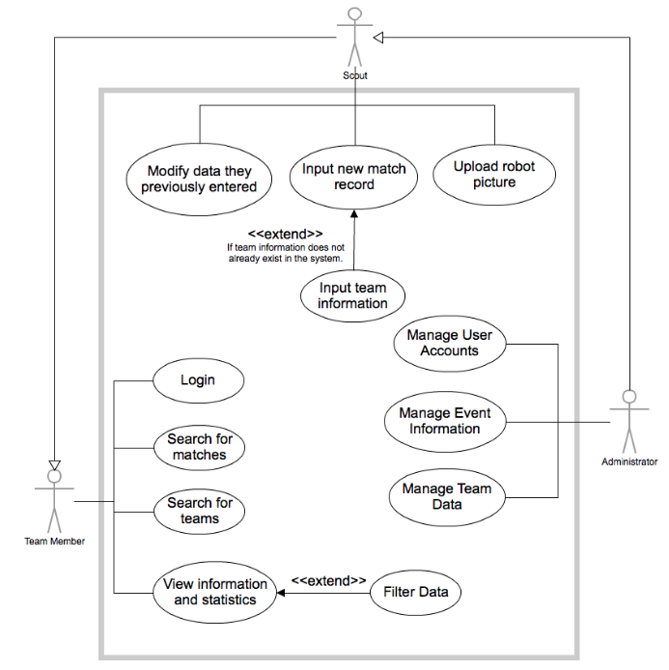

**Figure 5.1** Use Case Diagram

## 5.1 Use Cases For All Users

### 5.1.1 Login

**Preconditions**

* An account for the user must exist in the system (see 0100)

**Main Flow:**

1. A user must input an e-mail address and password, as described in [0140-0150], and click login.
2. If the e-mail address and password do not match those of an existing user, the system presents an error message to the user and the user remains on the login page. The user may repeat this process until valid login information is entered.
3. Otherwise, the user is taken to the event overview page (Figure 3.3.2), which has pre-selected the most recent event and is populated with the event data.

### 5.1.2 View information and statistics

**Preconditions**

* The user must be logged in
* The user has either the team member, scout or administrator user role.

**Main Flow**

1. Users can select to view information either grouped by event or grouped by team.
2. If a user selects to group information by event, statistics can be seen from one of three pages: the event overview page (Figure 3.3.1), match view page, or team view page.
3. Otherwise, if the user selects to group information by team, the system will present a team profile page and the option to view all of a team’s recorded matches.

**Subflow**

**Grouped By Event:**

1. The user can change the selected event by selecting an event from a menu then clicking an update button to re-populate the data tables and charts with information related to the new event that has been selected.
2. The user can switch between viewing the event overview, match and team information without having to reselect the event.

**Viewing an Event Overview:**

1. The user can view a table that contains data pertaining to which teams were present at the selected event and the number of points each team scored.
2. The user can view the data in the form of a graphical chart.

**Viewing a Match:**

1. The user can select a match to view for the selected event by searching for it by its match number.
2. The user can view tables (one for teams in the blue alliance and one for teams in the red alliance during the match) containing team numbers and a breakdown of points scored by each team.
3. The user can then select a team from one of the grids and click to view the full match record entered, which will redirect him to a page with all of the match record data originally entered by a scout.

**Viewing a Team:**

1. The user can select a team to view by searching for it by its team number.
2. The user can view tables and graphical charts that contain the matches the team participated in at the selected event, and points scored by that team during those matches.
3. The user can view the full match record by selecting a match from the grid and clicking view match record. The user will be redirected to a page containing the match record data originally entered by a scout.

**Grouped By Team:**

1. The user can select the team from a list, then click update to populate tables and charts with data collected about that team.
2. The user can change the selected team in the same way that the initial team was selected.
3. The user can switch between viewing the team profile and team’s matches without having to reselect the team.

**Viewing a Team Profile:**

1. The user can view a table populated with the total points scored by that team at each event, and a calculated average of the points scored.
2. The user can view pictures of the team’s robot, a line chart that shows a trend line with the team’s score over time, and a radar chart to compare the team’s proficiency at different types of point scoring.

**Viewing a Team’s Matches:**

1. The user can view a table containing all of the matches and total points per match that a team participated in.
2. The user can view the full match record by selecting a match from the grid and clicking to view match record. The user will be redirected to a page containing the match record data originally entered by a scout.

**View Match Record:**

1. The user can view all of the match record data originally entered by a scout (as detailed in [0560-0740]).
2. The user can click ‘Finished’ to return to the previous page.

### 5.1.3 Sort Data

**Preconditions**

* The user has logged in.
* The user has either the team member, scout or administrator user role.
* The user must be on a page containing a data table.

**Main Flow**

1. The user can sort data in a table by a datapoint in an ascending order by clicking the column header for that datapoint if the column is unsorted or in descending order.
2. The user can sort data in a table by a datapoint in descending order by clicking on the column header for that datapoint if the column is in ascending order (see previous bullet point).

### 5.1.4 Search for matches

**Preconditions**

1. The user has logged in to the system.
2. The user has either the team member, scout or administrator user role.
3. The user is on the View Match page for a certain event. (see 5.1.2: Viewing a Match)

**Main Flow**

1. The user can type a match number into a search field and click search.
2. If the match number was found, the page will populate data for that match.
3. Otherwise, a “Match found” message will appear.

### 5.1.5 Search for teams

**Preconditions**

* The user has logged in to the system.
* The user has either the team member, scout or administrator user role.
* The user is on the View Team page for a certain event. (see 5.1.2: Viewing a Team)

**Main Flow**

1. The user can type a team number into a search field and click search.
2. If the team number was found, the page will populate data for that match.
3. Otherwise, a “Team not found” message will appear.

### 5.1.6 Upload Robot Picture

**Preconditions**

1. The user has logged in to the system.
2. The user has either the scout or administrator user role.
3. The user is on the View Team Profile page for a certain event. (see 5.1.2: Viewing a Team Profile)

**Main Flow**

1. The user can click the ‘Upload picture’ button to upload a new picture.
2. The user can select a picture from the local hard drive of the computer he is using to be uploaded.
3. The user can click save or cancel.
4. If the user clicks save and the picture meets the size constraints (specified in 1050) and the user clicks OK when prompted that a previous team profile picture will be replaced with the new one, the picture will be saved in the system and will display on the team profile page
5. Otherwise, the user can select a different picture or click cancel

## 5.2 Use Cases for Scouts

### 5.2.1 Add Team

**Preconditions**

* The user has logged in to the system.
* The user has either the scout or administrator user role.

**Main Flow**

1. The user can enter team data, specified in [0440-0460]
2. If the user clicks save and the team number doesn’t match one already saved in the system, the team will be added to the system and the user will be redirected to the previous page
3. Otherwise, the team will not be added to the system and an error message will say “Team number already exists”
4. If the user clicks cancel, the entered data will not be saved and the user will be redirected to the previous page

### 5.2.2 Manage Previously Entered Match Record Data

**Preconditions**

* The user has logged in to the system.
* The user has either the scout or administrator user role.
* The user must be on the ‘Manage My Scout Data’ page.

**Main Flow**

1. The user can click add to add new match record data to the system, and will be redirected to the ‘Add new match record’ page (Figure 3.3.3).
2. The user can click edit to modify an existing match record in the system, and will be redirected to the ‘Edit match record’ page.
3. The user can click delete to remove an existing match record from the system.
4. If the user has the scout user role, he can modify or delete match record data only if it was originally added from his account.
5. If the user has the administrator user role, he can modify or delete match record data that any user has entered.

**Subflow**

**Add Match Record**

1. The user can select for which event, match, and team he is entering data.
2. The user can input data for all data points detailed in [0560-0730].
3. The user can use the mouse to draw a path on a picture of the arena [0740].
4. If the user clicks submit, the new match record data will be saved and he will be redirected to the previous page.
5. Otherwise, if the user clicks cancel the data will not be saved and he will be redirected to the previous page.

**Modify Match Record**

1. The user can select an existing match record to modify.
2. The user can change data for all data points detailed in [0560-0730].
3. If the user clicks save, the modified match record data will be saved and he will be redirected to the previous page.
4. Otherwise, if the user clicks cancel the data will not be changed and he will be redirected to the previous page.

**Delete Match Record**

1. The user can select an existing match record to delete.
2. If the user clicks delete, he will be prompted to confirm his decision to delete the entry.
3. If the user confirms his decision, the match record will be deleted from the system and will no longer be visible in the list of match records.
4. Otherwise, the match record will not be deleted and will remain on the list of match records.

## 5.3 Use Cases For Administrators

### 5.3.1 Manage User Accounts

**Preconditions**

* The user has logged in to the system.
* The user has the administrator user role.

**Main Flow**

1. The user can click add to add a new user to the system, and will be redirected to the ‘Add New User Account’ page.
2. The user can click edit to modify an existing account in the system, and will be redirected to the ‘Edit User Account’ page.
3. The user can click delete to remove an existing user account from the system.

**Subflow**

**Add Account**

1. The user can input data for all data points detailed in [0140-0180].
2. If the user clicks submit, the new user account will be created and he will be redirected to the previous page.
3. Otherwise, if the user clicks cancel the user account will not be created and he will be redirected to the previous page.

**Modify Account**

1. The user can select an existing account to modify.
2. The user can change data for all data points detailed in [0140-0180].
3. If the user clicks save, the modified user account information will be saved and he will be redirected to the previous page.
4. Otherwise, if the user clicks cancel the information will not be changed and he will be redirected to the previous page.

**Delete Account**

1. The user can select an existing account to delete.
2. If the user clicks delete, he will be prompted to confirm his decision to delete the account.
3. If the user confirms his decision, the account will be deleted from the system and will no longer be visible in the list of accounts
4. Otherwise, the account will not be deleted and will remain on the list of accounts.

### 5.3.2 Manage Event Information

**Preconditions**

* The user has logged in to the system.
* The user has the administrator user role.

**Main Flow**

1. The user can click add to add an event to the system, and will be redirected to the ‘Add Event’ page.
2. The user can click edit to modify an existing event in the system, and will be redirected to the ‘Edit Event’ page.
3. The user can click delete to remove an existing event from the system.

**Subflow**

**Add Event**

1. The user can input data for all data points detailed in [0310-0350].
2. If the user clicks submit, the new event will be added to the system and he will be redirected to the previous page.
3. Otherwise, if the user clicks cancel the event will not be added to the system and he will be redirected to the previous page.

**Modify Event**

1. The user can select an existing event to modify.
2. The user can change data for all data points detailed in [0310-0350].
3. If the user clicks save, the modified event information will be saved and he will be redirected to the previous page.
4. Otherwise, if the user clicks cancel the information will not be changed and he will be redirected to the previous page.

**Delete Event**

1. The user can select an existing event to delete.
2. If the user clicks delete, he will be prompted to confirm his decision to delete the event.
3. If the user confirms his decision, the event will be deleted from the system and will no longer be visible in the list of events.
4. Otherwise, the event will not be deleted and will remain on the list of events.

### 5.3.3 Manage Team Data

**Preconditions**

* The user has logged in to the system.
* The user has the administrator user role.

**Main Flow**

1. The user can click add to add a team to the system, and will be redirected to the ‘Add Team’ page.
2. The user can click edit to modify an existing team in the system, and will be redirected to the ‘Edit Team’ page.
3. The user can click delete to remove an existing team from the system.

**Subflow**

**Add Team: See 5.2.1**

**Modify Team**

1. The user can select an existing team to modify.
2. The user can change data for all data points detailed in [0440-0460].
3. If the user clicks save, the modified team information will be saved and he will be redirected to the previous page.
4. Otherwise, if the user clicks cancel the information will not be changed and he will be redirected to the previous page.

**Delete Team**

1. The user can select an existing team to delete.
2. If the user clicks delete, he will be prompted to confirm his decision to delete the team.
3. If the user confirms his decision, the team will be deleted from the system and will no longer be visible in the list of teams.
4. Otherwise, the team will not be deleted and will remain on the list of teams.